**DEEP LEARNING BASED ON FOOD IMAGE RECOGNITION AND PORTION SIZE DETERMINATION**

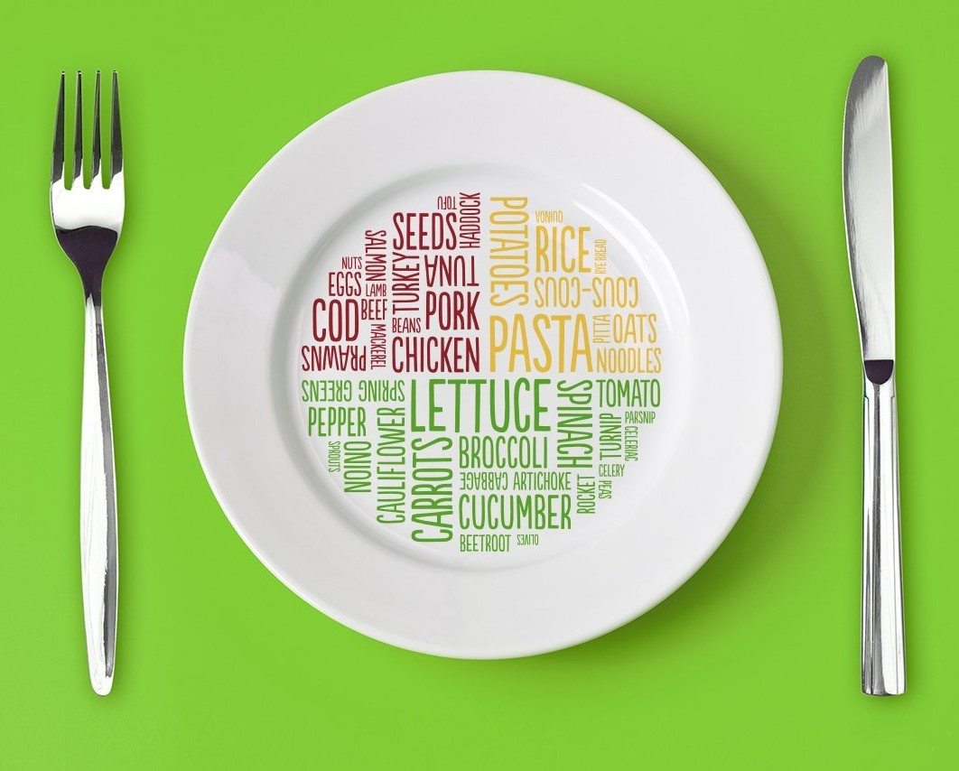

**Team Name : New Crew**

**Team Members :**

**Shreyaa Sridhar ( 21 )**

**Khushbu Kolhe ( 9 )**

**Geovanni Nicque West ( 23 )**

**Naga Venkata Satya Pranoop Mutha ( 15 )**

**IMPLEMENTATION**

**Clarifai API model**

Confusion Matrix generated

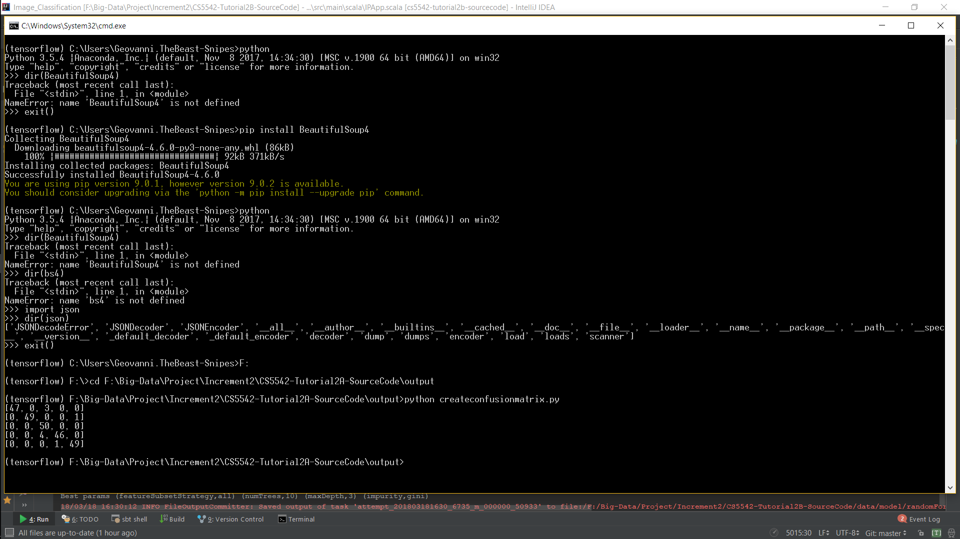

Accuracy of our model is **96.4%**

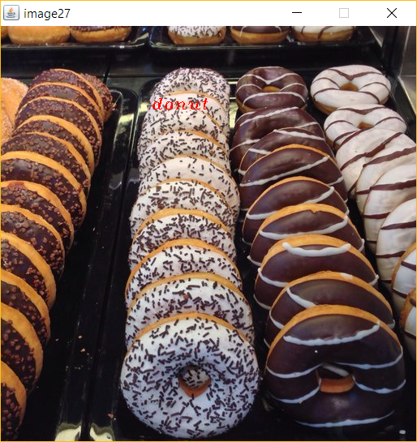 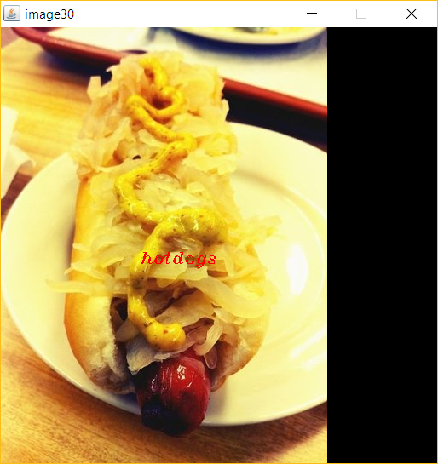

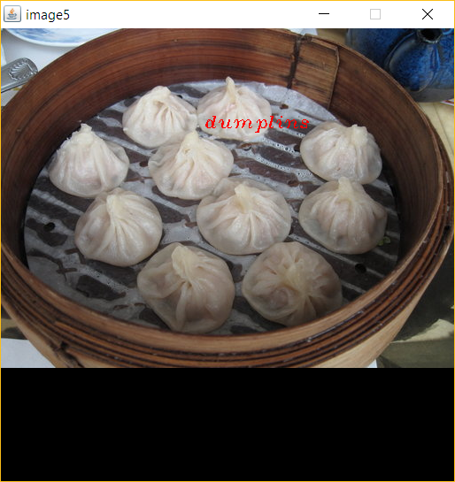 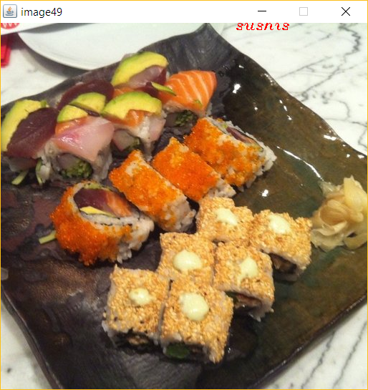

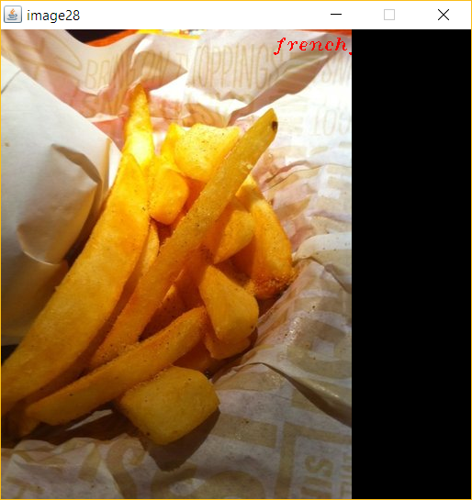

**Spark API model**

Spark best model, Random forest model. Accuracy of our model is **44.04%**

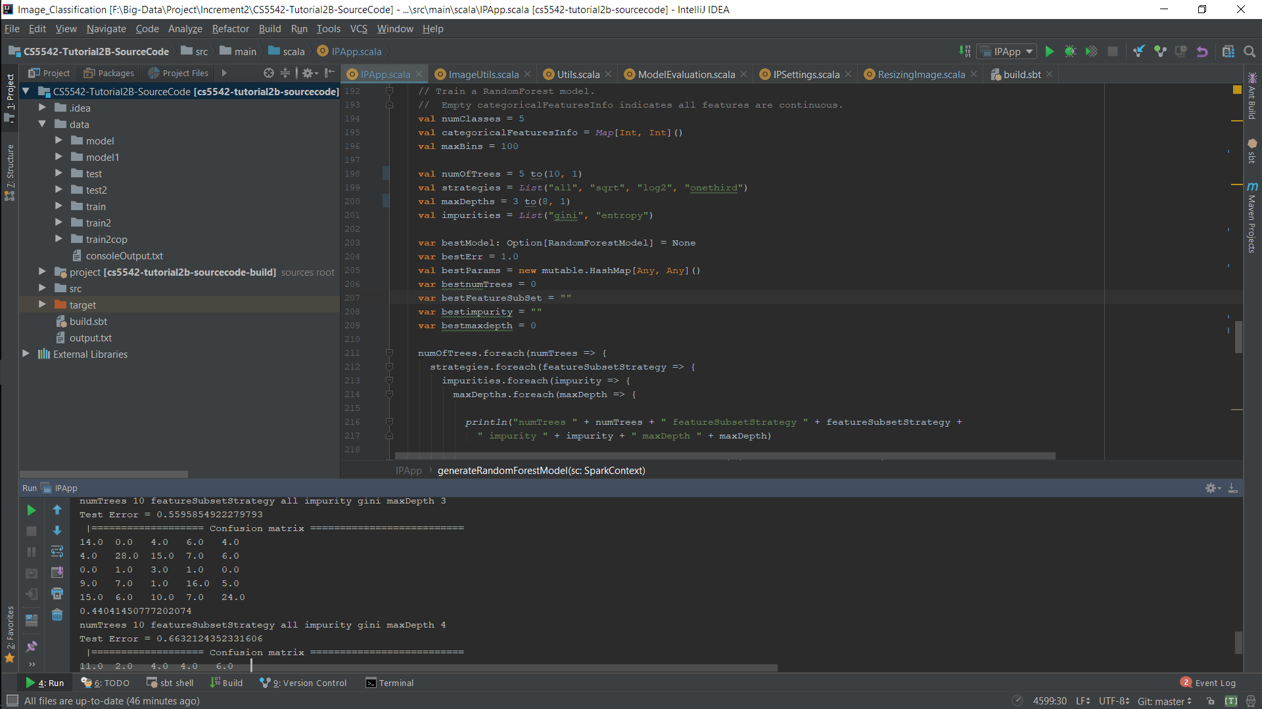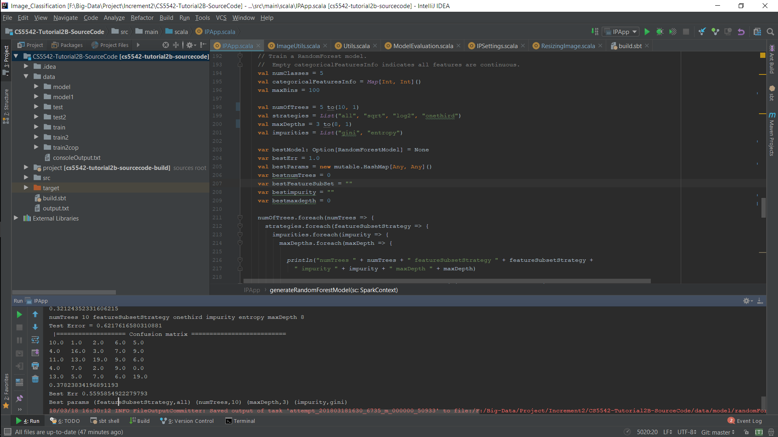

Food Image Prediction

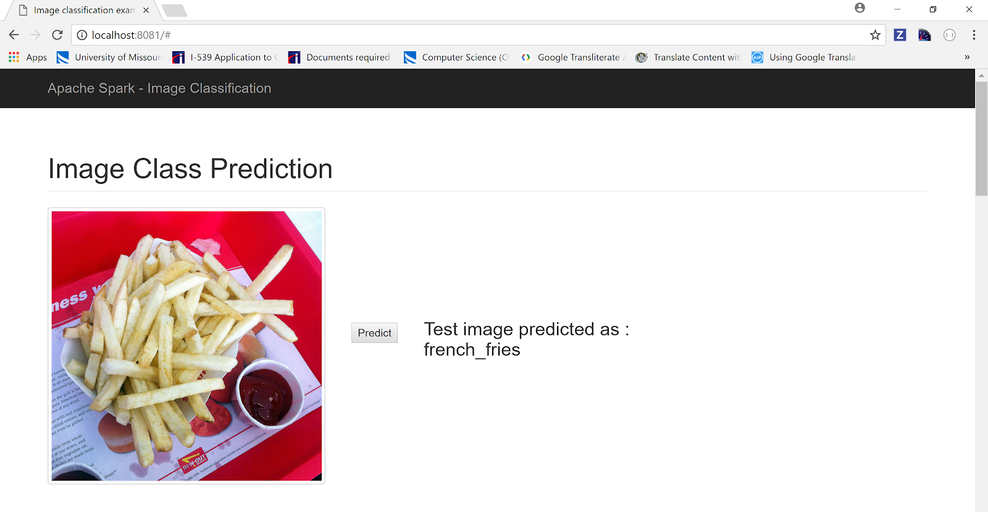

**Softmax Regression model**

Confusion Matrix was generated successfully.

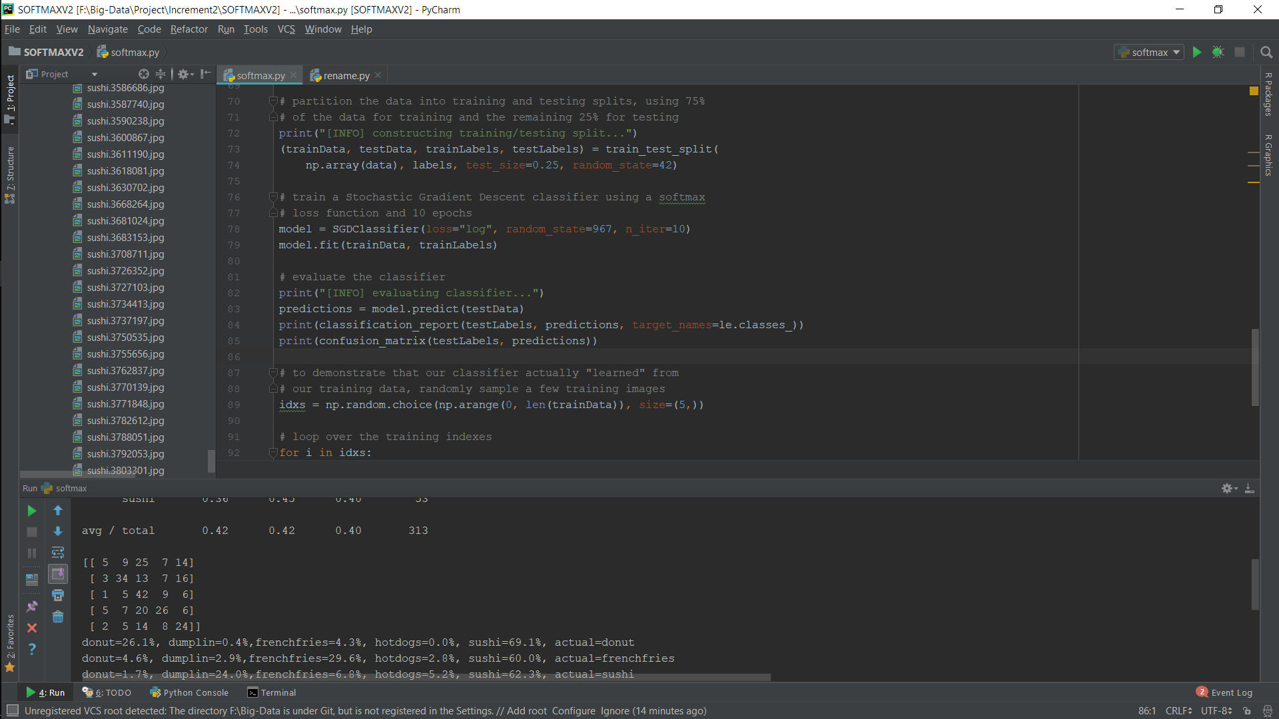

Accuracy of our model is **41.85%**

**CNN Model**

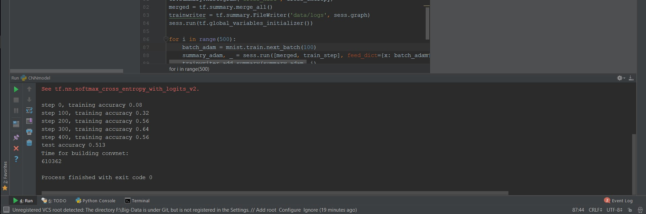

Accuracy of our model is **51.3%**

**PROJECT MANAGEMENT**

**Plan & Project Timelines, Members, Task Responsibility**

Shreyaa Sridhar ( 21 ) - 25%

Khushbu Kolhe ( 9 ) - 25%

Geovanni Nicque West ( 23 ) - 25%

Naga Venkata Satya Pranoop Mutha ( 15 ) - 25%

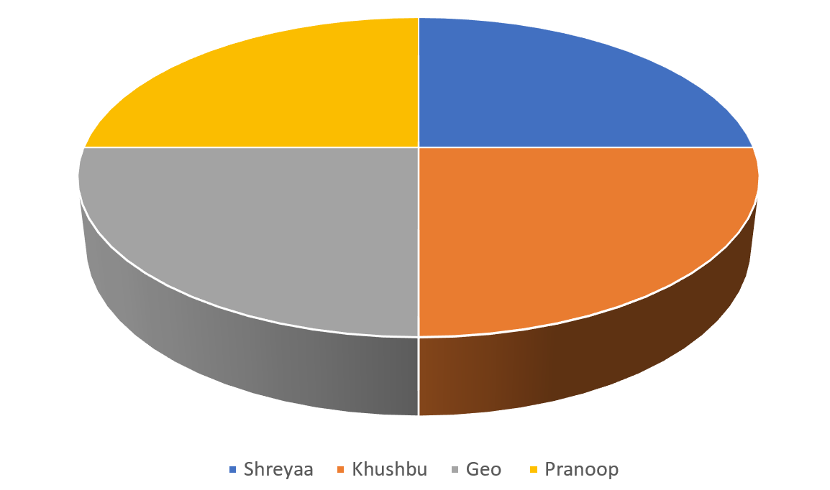

**REFERENCES**

<http://oar.a-star.edu.sg/jspui/bitstream/123456789/2299/1/05-NTCIR13-LIFELOG-XuQ.pdf>

<https://www.ncbi.nlm.nih.gov/pmc/articles/PMC5537777/>

<https://arxiv.org/ftp/arxiv/papers/1606/1606.05675.pdf>